How to Construct the Consumption Aggregate, Poverty Lines, and Poverty Estimates with the 2022 Suriname Survey of Living Conditions

By Carlos E. Sobrado

Employee Number: 123458 at the International Development Bank
Contract/Ticket Number: HRC0037157
Responsible Unit: CCB/CSU Country Office Suriname

Reports/Deliverables: 1 and 2

Virginia, USA
June 8, 2023

Table of Contents
1. INTRODUCTION 4
2. PROGRAMS 4
INPUT DATA FILES 4
Original Data Files 4
New Names For The Original Data Files 5
Inflation data files 6
2017 poverty lines file 6
SYNTAX FILES 6
DIRECTORIES 7
Directories for files 7
Directory references in the syntax files 8
RUNNING THE SYNTAX FILES 8
3. NEW DATA FILES 8
INTERMEDIATE FILES 8
FINAL DATA FILES 9
4. FLOW CHART FOR DATA AND SYNTAX FILES 10
5. BASIC CONSUMPTION AND POVERTY RESULTS 11
CONSUMPTION 11
POVERTY LINES, POVERTY, AND POPULATION 12

Introduction
This document includes a detailed description of the first two Reports/Deliverables from the IDB “PEC” contract with Carlos E. Sobrado, Contract/Ticket Number: HRC0037157, Responsible Unit: CCB/CSU Country Office Suriname; Start Date: March 30, 2023, Expiration Date: July 28, 2023.
As per the terms of reference included in Annex A of the contract, these Reports/Deliverables are:

i. Programs: “Econometric scripts used to calculate the consumption aggregates, poverty, and extreme poverty lines departing from the source raw datasets provided by IDB. Preference is for STATA programming language (do-files), but SPSS full programs are also acceptable.”
ii. New Data Files: “Updated databases containing the consumption aggregates, poverty, and extreme poverty lines (in both STATA and SPSS formats)”

Programs

Input data files

Original Data Files
The last version of the data files was received on April 20th, 2023, and included the following five STATA files:
RT001_weighted_Public.dta
RT002_weighted_Public.dta
RT140_weighted_Public.dta
RT141_weighted_Public.dta
RT142_weighted_Public.dta

In contrast with the 2016/17 survey, the 2022 the data files were organized according to the number of lines in each module: one question per household, one per person, one for each food item per household, one for each non-food item per household, and one for each shock per household. Some modules combine the number of lines for different questions; in those cases, the questions were placed in more than one data file. Table 1 indicates how the information for household survey modules was organized in the 5 data files.

Table 1 Questionnaire Modules Allocation in Data Files, Surinam SSLC 2022
Module | File | Subject | Notes
Modules with one question for each member
1 | RT002 | Demographics
2 | RT002 | Migration
3 | RT002 | Education
17 | RT001 | ICT (Technology) Part A | One question per household
17 | RT002 | ICT (Technology) Part B
4 | RT002 | Government and Social Safety Net Programs
5 | RT002 | Health
6 | RT002 | Pregnancy
7 | RT002 | Children
8 | RT002 | Crime and Safety
9 | RT002 | Employment
10 | RT002 | Income and Financial Inclusion
11 | RT002 | Personal Expenses
Modules with one question for each household
12 | RT001 | Agriculture and Animal Breeding
13 | RT001 | Housing
14 | RT140 | Household Consumption and Expenses: Part A | Food and Brev. in last 7 days
14 | RT141 | H. Consumption and Expenses: Parts B, C, D & E | Non-food, 30 days, 3 & 12 months
19 | RT001 | Food Insecurity
20 | RT001 | Shocks and Resilience: Q. 20.01 | Yes or No question
20 | RT142 | Shocks and Resilience: Qs. 20.02, 20.03 & 20.04
21 | RT002 | Attitudes
The sections listed here are in the same order as in the paper questionnaire

New Names for The Original Data Files
Beginning from the original Stata files, all the work was done using the statistical package SPSS. All programs and data files were run with SPSS. The files with the final estimates were saved in SPSS and Stata.
The original data files were renamed to facilitate their use. The new data files kept the first six digits of the original files (RT###_) followed by one or two words describing the type of information/organization in each file.
RT001_Housing_plus.sav
RT002_Persons.sav
RT140_Food.sav
RT141_Non_Food.sav
RT142_Shocks.sav

Inflation Data Files
A file was created with the Surinam CPI monthly inflation from 2016 to 2023. This file included five variables for each month and year: Consumer Price Index (CPI), CPI for food items, CPI for non-food items, the share of food items, and the share of non-food items. A second file with the CPI information for June 2017 and June 2022 information was created. The second file has five variables for each month/year: Consumer Price Index, CPI for food items, CPI for Non-food items, share of food items in CPI, and share of non-food items in CPI, for a total of 10 variables.
Table 2 Inflation Files Used for 2022 Estimates
File Name | Covering
Inflation CPI food and non food 2016 2023.sav | From April 2016 to February 2023
06 2017 CPI June 2017 and 2022.sav | June 2017 and June 2022

2017 Poverty Lines File
A third file with the poverty line estimates from the 2016/2017 household survey was included. The file has the estimated extreme and overall poverty line values estimated with the 2016/2017 household survey. Table 3 includes all the information in the data file.
Table 3 Contents of Data File “2017 Poverty lines.sav” Used for 2022 Estimates
Domain | line_extreme_2017 | line_moderate_2017 | Only1
1-Great Paramaribo | 265.29 | 733.1 | 1
2-Rest of the Coastal Region | 250.48 | 590.23 | 1
3-Interior | 206.69 | 533.27 | 1
Values are in June 2017 SRD

Sintax files
There are 10 SPSS syntax files with the commands to create the consumption aggregate, poverty lines and poverty classifications (equivalent to the STATA “DO” files). The name of each file starts with a number from 00 to 09, followed by a space and the name of the module being worked, or the process being performed or calculated.
The first syntax file creates a heading to be added to all the raw data files and saves the new files in a different directory with the new name (see list above under New Names for The Original Data Files). The first file also reviews the age and gender variables, adds a new household ID variable in numeric format (the original ID variable was a “String”), deletes two households without any consumption information (modifying the weight variable accordingly), creates a variable with the domain and subdomain information, and generates three variables with the day, month, and year of the last interview. The syntax file names are:
00 File names and heading 2022.sps
01 Education 2022.sps
02 Social programs 2022.sps
03 Health 2022.sps
04 Personal expenses 2022.sps
05 Food 2022.sps
06 House use value 2022.sps
07 Non food expenses 2022.sps
08 Aggregate 2022.sps
09 Poverty lines 2022.sps

There is also another Syntax file with the commands to estimate the Gini index for each Domain and for Surinam:
10 gini 2022.sps

Directories

Directories for Files
The main directories used by the syntax files are “C:\1 Suriname 2022\Data\SPSS” and “C:\1 Suriname 2022\Analysis”. Two other directories are used to store the original and final data files: “C:\1 Suriname 2022\Data\Stata” and “C:\1 Suriname 2022\Data\Final data”.
“C:\1 Suriname 2022\Data\SPSS” is used to place the original SPSS data files (5), inflation data files (2), and the file with the 2017 poverty line values (1). The STATA files were read directly into SPSS and saved in this directory. Only the first syntax file uses this directory.
“C:\1 Suriname 2022\Analysis” is for all other uses. The rest of the work is performed from, or saved in this directory, and has 39 data files: the original data files (5), the CPI and 2017 poverty files (3), the new heading files (4), the intermediate files (20), a “tailing” file (1) and the final files (6). The folder also has the 11 syntax files detailed earlier. The syntax file “09 Poverty lines 2022.sps” uses a third directory to store copies of the final products in SPSS and Stata: “C:\1 Suriname 2022\Data\Final data”.

Directory References in the Syntax Files
For all 11 syntax files, the first active command is “cd 'C:\1 Suriname 2022\Analysis”. To run the commands from a different directory/folder, change the first command line “cd 'C:\1 Suriname 2022\Analysis” to the new directory/folder name.
The full path was written for files located in other directories. The five original STATA files are opened using the full path: “GET STATA FILE='C:\1 Suriname 2022\Data\Stata\filename.dta”, and the supporting files are opened with “GET FILE='C:\1 Suriname 2022\Data\SPSS\name.sav”. If the files are placed in a different directory/folder, adjust the entire command accordingly.

Running the Syntax files
The programs were run using SPSS 25. The only requirements were to have the 5 original Stata files in “C:\1 Suriname 2022\Data\Stata\” and the 3 supporting data files in “C:\1 Suriname 2022\Data\SPSS\”, create the folders “C:\1 Suriname 2022\Analysis\”, and “C:\1 Suriname 2022\Data\Final data\”, and run the syntax files in sequential order from 0 to 10. No error messages were created. Warning messages were created by one syntax file regarding divisions by cero and the lack of combinations for some mean estimates. The final files with the consumption aggregate and poverty classifications were saved on a new folder: “C:\1 Suriname 2022\Data\Final data\”.

New data files

Intermediate files
After the first syntax file (00 File names and heading 2022.sps), the next seven (files 01 to 07) open different modules from the questionnaire to create the components for the consumption aggregate. Syntax file “08 Aggregate 2022.sps” puts together all the components. Syntax file “09 Poverty lines 2022.sps” creates the poverty lines and poverty classifications, and the final data files. The last syntax file “10 gini 2022.sps” estimates the Gini to measure inequality.
Syntax files 01 to 10 create two intermediate files (none for social programs, one for the Gini, and three for consumption). The intermediate file names start with a sequential letter (from “a” to “k”) followed by a description and ending in numbers 1 or 2 (consumption files have 0, 1 and 2). The highest number file has the final estimate (Table 4). File “j Poverty2.sav” has the final consumption aggregate values, poverty lines, quintiles, deciles, FGT values, poverty groups, etc.
Table 4 Intermediate Files for Consumption Aggregate and Poverty Lines
Syntax File Name | Output File 1 | Output File 2 | Output File 3
00 File names and heading 2022.sps | 12: new names for STATA files (5) + 2017 poverty lines (1) + inflation (2) + heading (4)
01 Education 2022.sps | a Education_1.sav | a Education_2.sav
02 Social programs 2022.sps | none (information not used)
03 Health 2022.sps | c Health_1.sav | c Health_2.sav
04 Personal expenses 2022.sps | d P_Expenses_1.sav | d P_Expenses_2.sav
05 Food 2022.sps | e Food1.sav | e Food2.sav
06 House use value 2022.sps | f House1.sav | f House2.sav
07 Non food expenses 2022.sps | g NonFood1.sav | g NonFood2.sav
08 Aggregate 2022.sps | h Consumption0.sav | h Consumption1.sav | h Consumption2.sav
09 Poverty lines 2022.sps | I 2017 Poverty lines0.sav  i 2017 Poverty lines1.sav | j Poverty1.sav &  j Poverty2.sav | tailing.sav *
10 gini 2022.sps | k GINI.sav
Total of 11 syntax & 33 output files. | 12
 | 10 | 9 | 2
* File used to add the ending (tail) to all original data files and to the consumption aggregate file

Final data files
Finally, all the 5 original data files were merged with the information from “j Poverty2.sav” file to include the new weights, quintile, decile and centile classification, inflation index, per capita consumption aggregate (food, non-food and total), poverty lines values, and poverty classification: extreme poor, total poor, and both.
The six final data files were saved with the same name but starting with “2022_”. Households without consumption aggregate were deleted from the files, and the weights were adjusted accordingly. The file names are:
2022 h Consumption2.sav
2022 RT001_Housing_plus.sav
2022 RT002_Persons.sav
2022 RT140_Food.sav
2022 RT141_Non_Food.sav
2022 RT142_Shocks.sav
The same files were saved in STATA format (dta extension)

Flow chart for data and syntax files
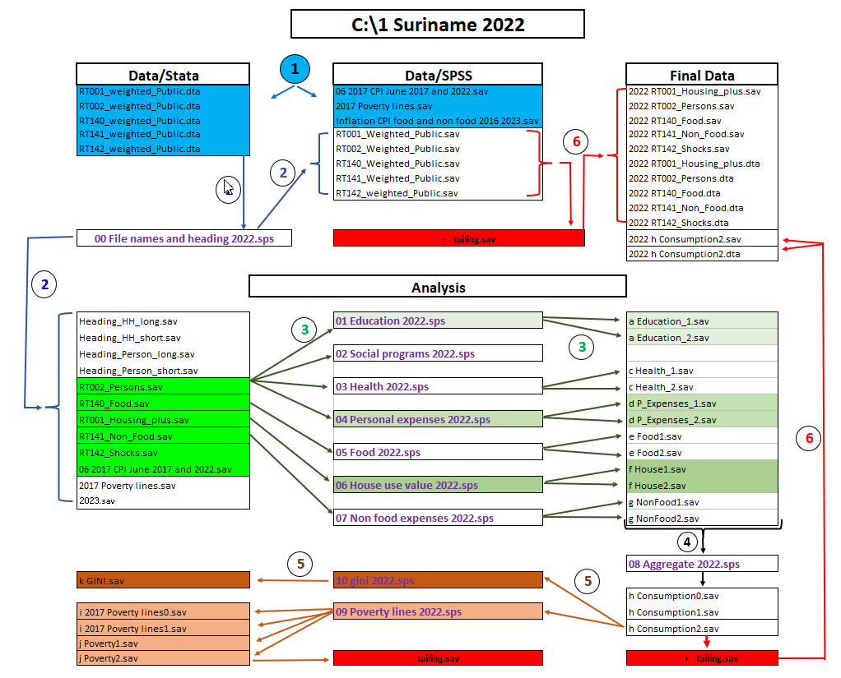
Note: Data file “06 2017 CPI June 2017 and 2022.sav” is used for the intermediate files (a, c, d, e, f and g). Data files “2017 Poverty lines.sav” & “Inflation CPI food and non food 2016 2023.sav” are used in “09 Poverty lines 2022.sps” syntax file.

Basic consumption and Poverty Results

Consumption
Figure 1 Per Capita Consumption and Household Size by Quintile, Surinam SSLC2022
Household 10200870501 excluded due to size distortions

Table 5 Consumption (PC/Month/June 2022 SRD) by Domain, Surinam SSLC 2022
 | Great Paramaribo | Rest of coastal R. | Interior | Total SRD | Total %
Food | 2,293.15 | 1,931.68 | 1,781.14 | 2,172.63 | 43.1%
Rent or use value of the house | 438.78 | 257.20 | 289.82 | 388.07 | 7.7%
Fuel, light, gas, and water at home | 136.84 | 115.29 | 40.61 | 123.69 | 2.5%
Education | 111.10 | 71.62 | 33.71 | 95.99 | 1.9%
Health | 149.44 | 80.31 | 15.47 | 123.12 | 2.4%
Transportation | 1,084.42 | 878.33 | 873.24 | 1,023.03 | 20.3%
Communication | 339.48 | 297.93 | 332.89 | 330.37 | 6.6%
Cleaning supplies, personal care, clothing, etc. | 493.11 | 372.03 | 439.95 | 463.48 | 9.2%
Equipment, electronics, furniture, glassware, etc. | 70.54 | 56.68 | 54.75 | 66.27 | 1.3%
Entertainment, services, games, celebrations, etc. | 158.80 | 75.85 | 40.73 | 131.09 | 2.6%
Other consumption | 136.54 | 112.87 | 55.79 | 124.36 | 2.5%
Consumption (pc/month/June 2022 SRD) | 5,412.21 | 4,249.80 | 3,958.10 | 5,042.10 | 100%

Poverty lines, poverty, and population
Table 6 Poverty Line Values (Month/Per Capita/June 2022 SRD), Surinam 2022
 | Domain |  |  |  | Average
 | Great Paramaribo | Rest of Costal R. | Interior
Extreme poverty line | 1,011.00 | 954.54 | 787.67 | 979.16
Overall poverty line | 2,659.82 | 2,152.02 | 1,938.72 | 2,490.34

Table 7 Poverty Headcount, Gap and Gap Squared (FGT), Suriname, 2022
 |  |  | Great Paramaribo |  | Rest of Costal R. |  | Interior |  | Total
Overall Poverty (PERSONS)
Headcount rate (P0) |  |  | 19.5% |  | 22.8% |  | 36.9% |  | 21.7%
Poverty gap index (P1) |  |  | 0.066 |  | 0.055 |  | 0.109 |  | 0.068
Poverty gap squared (P2) |  |  | 0.031 |  | 0.024 |  | 0.055 |  | 0.031
Extreme Poverty (PERSONS)
Headcount rate (P0) |  |  | 1.9% |  | 3.2% |  | 6.3% |  | 2.6%
Poverty gap index (P1) |  |  | 0.0047 |  | 0.0082 |  | 0.0189 |  | 0.0067
Poverty gap squared (P2) |  |  | 0.0014 |  | 0.0027 |  | 0.0083 |  | 0.0023
Overall Poverty (HOUSEHOLDS)
Headcount rate (P0) |  |  | 14.2% |  | 16.5% |  | 25.7% |  | 15.9%
Poverty gap index (P1) |  |  | 0.044 |  | 0.038 |  | 0.079 |  | 0.046
Poverty gap squared (P2) |  |  | 0.019 |  | 0.016 |  | 0.037 |  | 0.020
Extreme Poverty (HOUSEHOLDS)
Headcount rate (P0) |  |  | 1.1% |  | 1.9% |  | 3.2% |  | 1.5%
Poverty gap index (P1) |  |  | 0.0026 |  | 0.0048 |  | 0.0080 |  | 0.0036
Poverty gap squared (P2) |  |  | 0.0007 |  | 0.0015 |  | 0.0033 |  | 0.0012
Table 8 # of Persons and Households by Domain, Surinam SSLC 2022
 |  | Domain
 |  | Great Paramaribo |  | Rest of Costal R. |  | Interior |  | Total
Persons | Number | 435,419 |  | 126,610 |  | 56,122 |  | 618,151
 | Percentage | 70.4% |  | 20.5% |  | 9.1% |  | 100.0%
Households | Number | 113,409 |  | 33,655 |  | 17,830 |  | 164,894
 | Percentage | 68.8% |  | 20.4% |  | 10.8% |  | 100.0%

In 2016/17 most of the data files included one module of the questionnaire, for a total of 12 data files.
The word “plus” refers to single questions or filters (one per household) at the start of other modules.
The terms “directory” and “folder” are interchangeable and refer to the place, position, or path where files are stored.
After 2020, the SPSS package added the ability to read Stata files directly without the need to first “translate” them with programs like “Stat Transfer”. The Stata files were saved in the directory “C:\1 Suriname 2022\Data\Stata“
Writing the full path overwrites the CD command.

